CITY OF CARSON, CALIFORNIA
701 E. Carson Street, Carson CA 90745
NOTICE OF INVITATION FOR BID (IFB): IFB 24-07

Notice is hereby given that the Purchasing Manager of the City of Carson will receive formal bids for:

PROJECT NO. 1731 CARSON CITY HALL BASEMENT RENOVATION

Issue Date: 04/05/24
Mandatory Job Walk: 04/17/24 | 09:00 AM
Prospective Contractor Questions Due: 05/02/24 | 10:00 AM
Bids Due (Electronic Only): 05/20/24 | 09:00 AM

BIDS MUST BE SUBMITTED ELECTRONICALLY

NO LATE BIDS WILL BE ACCEPTED. Bids received after the due date and time will not be considered for this project. It is the policy of the City of Carson to reject any bid that is received late. BIDS MUST BE SUBMITTED ELECTRONICALLY USING PLANETBIDS. TO ACCESS AND REGISTER FOR THIS BID, PLEASE VISIT THE CITY’S PLANETBIDS PORTAL AT: https://pbsystem.planetbids.com/portal/32461/portal-home

TO VIEW OTHER BIDDING OPPORTUNITIES FROM THE CITY OF CARSON, PLEASE VISIT: http://ci.carson.ca.us/Finance/Bidding.aspx AND CLICK ON THE LINK "BIDDING/RFP OPPORTUNITIES".

All questions or request for interpretation regarding this RFP solicitation must be submitted online through PlanetBids within the date and time specified. Bidders are not to contact City personnel or Elected Officials with any questions or clarifications concerning this RFP other than through PlanetBids. Any City response for this RFP that is not posted through PlanetBids is unauthorized and will be considered invalid.

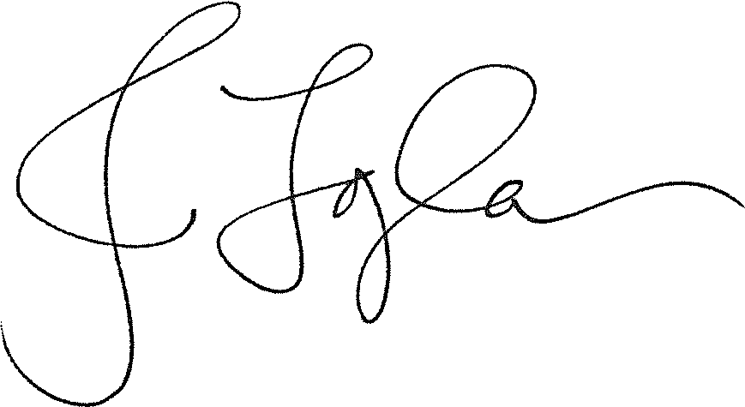
Josilla Togiola
Purchasing Manager
April 5, 2024

